|  |  |  |
| --- | --- | --- |
| **Name:** **MUHAMMAD MAZIZI BIN MAZLAN** | | **Section : 3** |
| **ID Number: AM2307013954** | |
| **Lecturer: MADAM SITI ROBAYA BINTI JANTAN** | | **Lab group / Tutorial group / Tutor (if applicable):** |
| **Course and Course Code:**  **FUNDAMENTAL OF PROGRAMMING (SWC1323)** | | **Submission Date:**  **8/12/2023** |
| **Assignment Title:**  **LAB WORK 1** | | **Extension & Late submission:**  **Disallowed** |
| **Assignment Type:**  **INDIVIDUAL** | **% of Assignment Mark**  **15%** | **Returning Date:** |
| **Penalties:**   1. 10% of the original mark will be deducted for every one week period after the submission date. 2. No work will be accepted after two weeks of the deadline. 3. If you were unable to submit the coursework on time due to extenuating circumstances you may be eligible for an extension. 4. Extension will not exceed one week. | | |
| **Declaration**: I/we the undersigned confirm that I/we have read and agree to abide by these regulations on plagiarism and cheating. I/we confirm that this piece of work is my/our own. I/we consent to appropriate storage of our work for checking to ensure that there is no plagiarism/ academic cheating.  **Signature: ____________**  **Full Name: MUHAMMAD MAZIZI BIN MAZLAN** | | |
| **This section may be used for feedback or other information** | | |



**QUESTION 1:** Given the following C++ program: The program is designed to ask the user to enter his age. However, there are bugs in the programs that may cause them to give incorrect results for some inputs. Think about possible bugs for example what happens if you enter a negative number in this code, and so on. Therefore, your job is to identify bugs and debug the program so that it fixes the program accordingly. After debugging it, describe the problem and how you solved it (Provide the improved C++ code with appropriate comments and display your sample output). (8 marks)

#include <iostream>

using namespace std;

int main() {

int age; cout << "Enter your age: ";

cin >> age;

// ... rest of the code

return 0;

}

**Here is the improved C++ code :**

#include <iostream>

#include <limits> // Include the necessary header for numeric_limits

using namespace std;

int main() {

int age;

// Prompt the user to enter their age

cout << "Enter your age: ";

// Input validation loop

while (!(cin >> age) || age < 0) {

// If the input is not a valid integer or is negative, display an error message

cout << "Invalid input. Please enter a valid non-negative integer for your age: ";

// Clear the error flag and discard invalid input

cin.clear();

cin.ignore(numeric_limits<streamsize>::max(), '\n');

}

// At this point, 'age' contains a valid non-negative integer

// Rest of the code can be added here

cout << "Your age is: " << age << endl;

return 0;

}

**Explanation of the improvement :**

1. **Input Validation Loop**: We use a ‘while’ loop to repeatedly prompt the user for input until a valid non-negative integer is entered.
2. **Error Handling**: If the input is not a valid integer or is negative, an error message is displayed, and the input stream is cleared (cin.clear()) to handle the error state. We also use cin.ignore() to discard any invalid input.
3. **Display Age**: After the loop, the program can continue with the rest of the code. In this example, it simply displays the entered age.

**SAMPLE OUTPUT :**

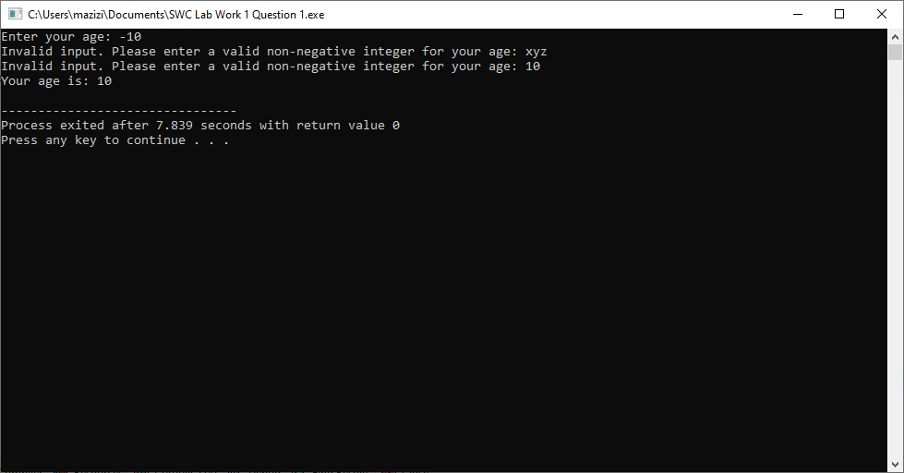

**QUESTION 2:**

A tetrahedron is a three-dimensional figure with three triangular sides and a triangular base. Sometimes referred to as a triangular pyramid or three-sided pyramid, a tetrahedron has six edges and four vertices.

Write a C++ program to find the volume of 3 tetrahedron using a while loop. The shape of the tetrahedron and the formula are shown in Figure 1. The value of a will be input by the user. Print your code and sample output. (Please follow the best practice of writing your C++ program)

**Here is the C++ code :**

**#include <iostream>**

**#include <cmath>**

**using namespace std;**

**int main()**

**{**

**double sideLength;**

**cout << "Please enter a number: " << endl;**

**cin >> sideLength;**

**if (sideLength > 0)**

**{**

**double volume = (pow(sideLength, 3)) / (6 * sqrt(2));**

**cout << "The volume of the tetrahedron is: " << volume << endl;**

**}**

**else**

**{**

**cout << "Invalid input. Please enter a positive number for the side length." << endl;**

**}**

**return 0;**

**}**

**SAMPLE OUTPUT :**

